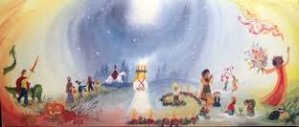

Gradalis EC Week July 12-17 with Mindy Upton

8:30-9 seasonal songs
9-9:45 watercolor painting (color wheel introduced with color painting
story from Monday through Friday starting with yellow, yellow /red, blue, blue/red, rainbow day with all three colors.
Each day a color fairy will appear with color story for that day
culminating with rainbow fairies dancing in a ring with all colors of the rainbow.
9:45-11:20
Monday- Child development, development of play (articles to be read to accompany each day)
Tuesday-Movement development; the sequential movement progression from birth to standing, importance of Play
Wednesday-Domestic and Nurturing Arts; baking, cooking, serving, rituals for snack and lunchtime, woodworking, teachers toolbox.
Thursday-Power of Story, nature stories, pedagogical story, birthday stories and age appropriate fairy tales.
11;30-12;30 Lunch
12; 45 – 2:00 Monday through Friday Circle/Ring Time through the sesaons
2-4 Handwork; simple dolls, molded head dolls, felted puppets, simple rod puppet
4-5 Monday-Friday Discussion of Teachers Role; discipline, rhythm in the classroom, outside play, parent nights.
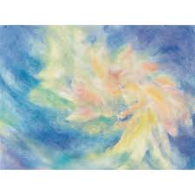
Students will receive a packet of articles to be read prior to
the workshop. These will be sent via email.
Students will bring their sewing kits to class which
will include needles, scissor, thread, and felting needle and sponge.
If students would like to create a story apron during the handwork
section they can do so and bring their own apron to embellish
All other materials will be supplied by the workshop.

